Simple MBC of Mixing Tank Level and Composition
Case Study, Simulation Code, and Simulator Instructions
R. Russell Rhinehart
2024-02-02

Application and controller model

The nonlinear process for this study is the titration of a wild flow to meet a composition set point. Mixing is in a tank, and level must also be controlled. Figure 1 is a P&ID for the process. Wild flow enters the mixing tank on the left, with flow rate Fw and composition zw. Titrant fluid enters from the right, with flow rate Ft and composition zt. The liquid level in the tank, measured by LT, and the outlet composition, measured by AT, need to be controlled. The model-based controller (not shown in the P&ID) will decide values for the titrant and outlet flow rates and send them as set points to the PI secondary flow controllers (FCs) for the titrant inflow and product outflow measured by FTs.

Certainly, the model-based controller can send signals directly to the titrant and outlet flow control valves, but that requires an extra step of modeling flow rate as a function of valve position and line pressure drop. The cascade arrangement comfortably reverts to classic control if the model-based controller is taken offline, and since the secondary PI controllers contain all the desired auxiliary features such as communication protocol, data validity checks, etc., the process engineer does not need to code those in the supervisory model-based controller.

Wild, Fw, zw
Titrant, Ft, zt
FC
FC
FT
FT
Ft SP
Fo SP
AT
LT
Figure 1 – Process Illustration

The simple first-principles models representing the tank level, $h$, and outlet concentration, $z_{o}$, are developed from material balances around the tank. This effort may take a reader back to college skills. Hopefully, this calculus-free trip will be enjoyable.

A model for liquid level starts with an overall mass balance. The mass that flows in, less what flows out, is the mass that accumulates in the tank. In a time-interval, $∆t$, the equation for the material balance is:

$F_{w}ρ_{w}∆t+F_{t}ρ_{t}∆t-F_{o}ρ_{o}∆t={\left.hAρ_{in}\right|}_{t+∆t}-{\left.hAρ_{in}\right|}_{t}$ (1)

Here, $F$ represents flow rate, and $ρ$ density. The subscripts $w$, $t$, and $o$ refer to the wild flow, the titrant, and the out-flow. $h$ represents the height of the fluid in the tank, of cross-sectional area $A$. The notation ${\left.x\right|}_{t}$ means the value at the beginning of the time-interval, $∆t$, and ${\left.x\right|}_{t+∆t}$ means at the end of the time-interval. Classic model simplifications are that there is no density change due to mixing, and that the tank is perfectly mixed so that the fluid composition flowing out of the tank, $z_{o}$, is the same as that in the tank, $z_{in}$, and that the cross-sectional tank area, $A$, does not change with time or liquid level. Divide by density, divide by $∆t$, and take the limit as $∆t$ becomes very small, and rearrange to the conventional differential equation form.

$A\frac{dh}{dt}=F_{w}+F_{t}-F_{o}$ (2)

However, since the flow rates change over time in nonanalytical manners, Eq. (2) cannot be solved analytically. Instead of using Eq. (2) to solve for how $h$ changes in time, do not divide Eq. (1) by $∆t$, divide by A and density, to obtain a classic numerical solution method for the differential equation (which is termed Euler’s explicit, or alternately a forward finite difference method).

${\left.h\right|}_{t+∆t}={\left.h\right|}_{t}+∆t{\left.\left[{(F_{w}+F_{t}-F_{o})}/A\right]\right|}_{t}$ (3)

Eq. (3) is the first principles dynamic model for the tank level. The reader may be very pleased that neither calculus nor analytical solutions of a differential equation are involved with control or control modeling. Nor are Laplace transforms!

The differential equation representing how concentration in the tank changes in time is similarly developed from a component mass balance. The component mass that flows in, less what flows out is the component mass that accumulates in the tank in a time interval, $∆t$. The equation is:

$F_{w}z_{w}∆t+F_{t}z_{t}∆t-F_{o}z_{o}∆t={\left.hAz_{in}\right|}_{t+∆t}-{\left.hAz_{in}\right|}_{t}$ (4)

With the same classic simplifications, rearrange to a differential equation form.

$\frac{dhz_{o}}{dt}={\left[F_{w}z_{w}+F_{t}z_{t}-F_{o}z_{o}\right]}/A$ (5)

Since both $h$ and $z_{o}$ change in time, using the calculus product rule $\frac{dhz_{o}}{dt}$ becomes $h\frac{dz_{o}}{dt}+z_{o}\frac{dh}{dt}$. Using $\frac{dh}{dt}$ from Eq. (2), Eq. (5) becomes

$\frac{dz_{o}}{dt}=\left[F_{w}\left(z_{w}-z_{o}\right)+F_{t}\left(z_{t}-z_{o}\right)\right]/hA$ (6)

Again, although Eq. (6) would be a conventional calculus presentation of the model, it cannot be solved analytically. Instead, use a classical numerical solution method.

${\left.z_{o}\right|}_{t+∆t}={\left.z_{o}\right|}_{t}+∆t{\left.\left\{{\left[F_{w}\left(z_{w}-z_{o}\right)+F_{t}\left(z_{t}-z_{o}\right)\right]}/{Ah}\right\}\right|}_{t}$ (7)

Eqs. (3) & (7) represent the model that would be in the model-based control (MBC) algorithm.

The Process Simulator

The model in the controller should not be the same as the model in the process simulator. Any real physical process will have many confounding and un-modeled features. The simulated process here has dead zones in the mixer and composition measurement lag. The simulated process has density change in the mixing, and the true value of the tank cross-sectional area is affected by insertions, baffles, the mixing impeller, support ridges, and dents in the tank. The measured flow rates and measured level have noise and drifting calibration error, and are filtered to temper noise. The wild flow rate and its composition both vary in time, and the composition is not measured. There are small mass losses due to evaporation, splashing, or leaks. The titrant composition is not exactly the nominal value that it is presumed to be. Dynamics of the secondary flow controllers and valves are not included in the controller model, but are in the process simulator. The process has a dominant lag due to in-tank mixing, but lags due to dead zone material exchange with the active zone, valves, measurements, controllers, and noise filters combine to make the process have a 5th order response to inputs.

Figure 2 illustrates the process-to-model mismatch as well as process nonlinearities. In the figure, the supervisory controller is in manual mode (MAN) and makes equal magnitude steps in the flow rate set point to the titrant flow controller. The two solid lines in the lower part of the figure are the set point to the outlet flow controller (held constant) and to the titrant flow controller (making step changes). The process and controller model responses are the four upper traces. Dotted lines represent the true process values of the simulator. Although they could be measured, sensor lags, noise, calibration bias, and filtering provide errors and lags in the measured value. True values are unknowable, hence dashed lines here. The trapezoidal trends in Figure 2 represent the integrating aspect of the tank level, and the first-order like trends represent composition.

Figure 2 reveals that the process is nonlinear and non-stationary. Although the steps in the set points from the supervisory controller have identical magnitudes, the rate of change for the tank level shows about a 5:1 change. Notice the fast response of the composition to the first step up in the influence about 100 sec, and the slower response of the equivalent but opposite second step at about 300 sec. Also note the longer yet time-constant and larger gain change of the third step down of equal magnitude. The effective settling time for the composition response also has about a 5:1 change, and the gain change has about a 2:1 ratio.

Figure 2 also reveals that the modeled CV values are not the same as the process. This is more evident for the composition but the modeled level lags behind by about 5 s. Since we can hardly ever model all the complications in a real process, it would be “cheating” to test a controller with the same model in the simulator as in the controller, and no measurement error. The mismatch in the modeled and true process indicates process-to-model mismatch. Although tradition with generating first-order plus dead time (FOPDT) models of the process using step tests labels the FOPDT model of the process as “the process”, and uses the subscript $p$ (for process) on the gain, time-constant, and deadtime, the model of the process used by a controller is not the process. The mismatch is somewhat greater between the controller model and the measured CV values. Measured values are all that the controller can know.

As well as being nonlinear, with variable time-constants, the process is interactive. As illustrated in Figure 2, changing one controller output to the titrant affects both CVs.

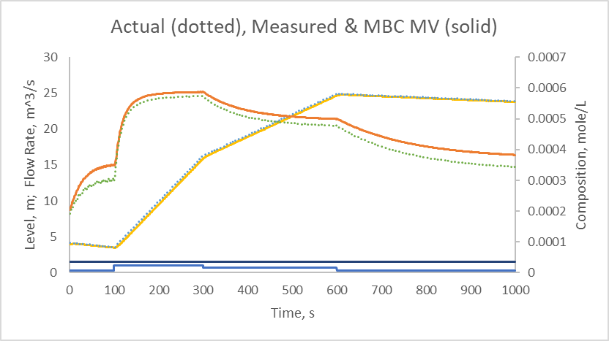

Figure 2 – Supervisory MBC in MAN with Steps in Titrant Flow Rate SP

The deterministic process is nonlinear, non-stationary, and interactive. When drifts and noise features are included, the simulator is even more challenging for control. Compare Figure 3 to Figure 2 to see the confounding effects of disturbances in the wild flow rate and composition to the process response.

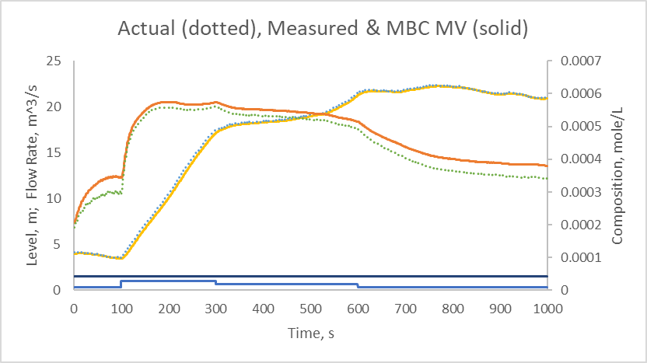

Figure 3 – Figure 2 with Disturbances to the Process

A Simple Model-Based Control Strategy

Figure 4 presents a block diagram of the controller strategy.
SP
SP Bias
Biased SP
MV
pmm
y_{process}
y_{model}
Action
Correct
Process
Predict

Override
-
+
+
-
Model Coefficient
Figure 4 – Simple Model-Based Control Strategy

Process

The block in the upper right represents the process. It receives the inputs from the controller, MV, and responds. Labeled as y_{process} are the measured CVs and auxiliary variable values. In this simulation, the process is simulated. Although, in a simulator one could display all the true process states and coefficients, in the real world all we can know are the reports from measurements, which is what as y_{process} represents.

Not shown, the process will also have many other inputs, such as a wild flow and environmental effects, and model will have those wild inputs that are measured. The process may have several outputs and the controller may have several MVs. So, the labels y and MV are not necessarily single valued. They may be vectors. In this 2X2 simulation they each have two values.

Controller Model

In the lower right, and processing data in parallel to the process block, is the block representing the controller model of the process. It is labeled “Predict”. It executes Eqs. (3) & (7) and predicts the current values of the process from the prior model predictions. It is a one-time-step prediction, updating the model predictions from the previous time step to the current time. The past-to-now function of the model is labeled P2N.

Process-to-Model Mismatch

The difference between the modeled and measured values are the process-to-model mismatch, pmm, values. The communication line labeled pmm has two values for the two modeled states – level and composition.

Correct

The pmm values are used in the block labeled “Correct” to generate a bias to adjust the set points for the MBC model. Since the model is not the same as the process, if the controller finds MV values that make the model hit the set point, the process will have a steady state offset. This simple model-based control adjustment to remove offset is analogous to an archer seeking to hit the center of a target. If the arrow falls 3 cm below the bull’s eye, next time aim 3 cm above. The lines labeled SP and Biased SP are also vectors, not single values. They represent desired values for the tank liquid level and the exit composition.

${pmm}_{z}=z_{measured}-z_{modeled}$ (8)
$z_{SP}^{'}=z_{biased SP}=z_{SP}-{pmm}_{z}$ (9)

${pmm}_{h}=h_{measured}-h_{modeled}$ (10)
$h_{SP}^{'}=h_{biased SP}=h_{SP}-{pmm}_{h}$ (11)

In Eqs. (9) & (11) the prime represents the biased set point for the model.

The Correct function could also filter the pmm value to temper process noise or dynamic mismatch.

${pmm}_{z filtered}=λ∙{pmm}_{z}+(1-λ)∙{pmm}_{z filtered}$ (12)
$λ=1-e^{-∆t/{taufilter}_{z}}$ (13)

${pmm}_{h filtered}=λ∙{pmm}_{h}+(1-λ)∙{pmm}_{h filtered}$ (14
$λ=1-e^{-∆t/{taufilter}_{h}}$ (15)

If a measured value is noisy, then just filtering the measured value, and not the controller model prediction, creates a dynamic lag and increases the process-model-mismatch. So, to eliminate this dynamic mismatch, filter the pmm, which equally lags the process measurement and modeled value. If it is desired to display a filtered measurement value to the operator, just filter the value that goes to the display. Use the unfiltered measurement value in the MBC.

In this simulation, the measured flow rate values include calibration bias. The measured flow rates are not the same as the true flow rate values affecting the process. So, even if the process is at steady state, the error in the measured values will make the modeled mass balance continually integrate up or down. The correct function uses a simple material balance data reconciliation to determine a fictitious outlet flow rate $F_{error}$. With this outflow correction, Eq. (2) becomes.

$A\frac{dh}{dt}=F_{w}+F_{t}-F_{o}-F_{error}$ (16)

Since the model does not know the true values, $F_{error}$ is simply estimated by reversing Eq. (16) and replacing the derivative with the finite difference equivalent:

$F_{error}=F_{w measured}+F_{t measured}-F_{o measured}-A_{modeled}\frac{{\left.h_{measured}\right|}_{t}-{\left.h_{measured}\right|}_{t-∆t}}{∆t}$ (17)

One could use any of many data reconciliation options. If $F_{error}$ is noisy, one could filter the $F_{error}$ value.

The Correct function might also adjust a model coefficient (such as the wild flow composition) to improve the model match to the process. If the model is continually corrected by adjusting a model coefficient or variable, then the model is a digital twin and becomes useful for predicting constrained limits, useful for on-line process monitoring for maintenance or efficiency, and useful for supervisory process economic optimization.

Action (simple)

The block labeled Action calculates MV values. It uses the controller model, biased set points, and desired rates for the model to move the modeled CV to the biased SP. When the models are first-order, as are Eqs. (3) & (7), then to calculate controller outputs, desire that the modeled CVs move to the biased SPs in a first-order manner. Here is how:

From a generic FO model:

$τ\frac{dx}{dt}+x=x_{SS}$ (18)

And rearranging with desired values for the steady state target and the time-constant to determine the desired rate of change:

${\left.\frac{dx}{dt}\right|}_{desired}=\frac{x_{desired target}-x}{τ_{desired}}$ (19)

The single tuning factor for each variable in MBC is the desired rate of change, the $τ_{desired}$ value.

For the composition, this desired rate of change is:

${\left.\frac{dz_{m}}{dt}\right|}_{desired}=\frac{z_{SP}^{'}-z_{m}}{τ_{desired for z}}$ (20)

For the height, this is:

${\left.\frac{dh_{m}}{dt}\right|}_{desired}=\frac{h_{SP}^{'}-h_{m}}{τ_{desired for h}}$ (21)

When substituted in the models (Eqs 3 & 7) and rearranged to solve for the desired MV values:

$F_{t desired}=\left[F_{w}\left(z_{w}-z_{o}\right)-hA\frac{z_{SP}^{'}-z_{m}}{τ_{desired for z}}\right]/\left(z_{t}-z_{o}\right)$ (22)

$F_{o desired}=F_{w}+F_{t}-F_{error}-A\frac{h_{SP}^{'}-h_{m}}{τ_{desired for h}}$ (23)

First use Eq. (22) to determine $F_{t desired}=F_{t SP}$, which is the set point for the titrant flow controller. Then use Eq. (23) to determine $F_{o desired}=F_{o SP}$, the set point for the outlet flow controller.

Although this is a 2X2 control strategy, the one-way coupling in the controller model permits sequential solutions. In other situations, the two equations must be solved simultaneously, and nonlinearities in the model or auxiliary variable constraints could require a root finding or an optimization procedure.

This use of the model in the ACTION function projects the modeled values into the future. Contrasting the P2N function this model considers now-to-future, and is termed N2F. The N2F model needs to be initialized with the most recent P2N model values at each search iteration.

Action (optimization)

The form of Equations (22) and (23) permit direct and sequential solution. However, the equations may be nonlinear and not separable. One method to solve for the MVs is root finding. However, Newton-like algorithms may send the trial solution off into the hinterland. A robust approach may be needed. A direct search (not a gradient-based method) optimization is recommended.

Further, there may be constraints. In this example these are rate-of-change on the MVs, or extreme values on the MVs (less than 0 of greater than the physical maximum flow rates), and tank level (not to overflow, or not to run near empty).

Additionally, when a combination of set points may not be achievable, making one MV hit a constraint, the process owner may want to use the remaining MV to provide a balance between the two CVs. For example, in this simulation, if the wild flow rate is high and the wild composition is low the titrant flow rate may need to be its maximum to get the mixed composition at the set point. But the two high inflow rates may be greater than the outflow rate maximum and the level may rise to the overflow limit. A solution to the problem could be to give up full control of the composition to prevent the tank level from rising.

In this simulation the nominal objective function (OF) is to determine the MVs that make the deviation from the desired rate-of-return-to-the-set-point have a zero value.

$\begin{matrix}min \\ \{F_{t desired}, F_{o desired}\}\end{matrix} J=∆_{1}^{2}+∆_{2}^{2}$ (24)

Where $∆_{1}^{2}$ and $∆_{2}^{2}$ are the squared deviation associated with Equations (22) and (23).

$∆_{1}^{2}={\left[F_{w}\left(z_{w}-z_{o}\right)-F_{t desired}\left(z_{t}-z_{o}\right)-hA\frac{z_{SP}^{'}-z_{m}}{τ_{desired for z}}\right]}^{2}$ (25)

$∆_{2}^{2}={\left[F_{w}+F_{t}-F_{error}-F_{o desired}-A\frac{h_{SP}^{'}-h_{m}}{τ_{desired for h}}\right]}^{2}$ (26)

Squaring the deviations means that whether they are negative or positive, the squared value is positive, and minimizing means that the deviations in Equations (22) and (23) goes to zero, if there are no constraints. The optimizer searches for the two MV values, $F_{t desired}$ and $F_{o desired}$ that make the delta terms each become zero. If unconstrained, the F-values that make the OF=0 are the same as the F-value solutions to Eqs. (22) and (23).

In optimization jargon, $F_{t desired}$ and $F_{o desired}$ are the decision variables (DVs). In control jargon they are the MVs. In optimization jargon, $J$ is the objective function (OF). An optimization algorithm uses guided “guesses” for the DV values to progressively adjust the DV values to minimize the OF. The DV guesses are termed trial solutions (TS).

If the units on the delta terms have different values, or if concern for one deviation is greater than for another, then weight the delta terms in Equ. (24) by equal concern factors (EC).

$\begin{matrix}min \\ \{F_{t desired}, F_{o desired}\}\end{matrix} J={\left(\frac{∆_{1}}{{EC}_{1}}\right)}^{2}+{\left(\frac{∆_{2}}{{EC}_{2}}\right)}^{2}$ (27)

If unconstrained, the solution does not change.

Constraints on the DVs can be “Hard”. For instance, if the TS is greater or lower than a limit, or if the rate-of-change in a DV exceeds a limit. The optimizer is told, “That violates a constraint. Guess again.” If the optimizer is a direct search type (as opposed to a gradient-type) then the hard constraints are easily managed.

However, there may also be constraints on response variables. For instance, tank level is a response to the DVs. If there are constraints on response variables, use the penalty method to temper violations. For instance, if high level in the tank is a constraint on the level response, the violation (V) of the constraint is:

$IF \left(h≤h_{upper limit}\right) THEN \left(V=0\right) ELSE (V=h-h_{upper limit})$ (28)

Then scale the violation by its EC factor and add it to the OF.

$\begin{matrix}min \\ \{F_{t desired}, F_{o desired}\}\end{matrix} J={\left(\frac{∆_{1}}{{EC}_{1}}\right)}^{2}+{\left(\frac{∆_{2}}{{EC}_{2}}\right)}^{2}+{\left(\frac{V_{1}}{{EC}_{3}}\right)}^{2}$ (29)

If there are other response variable constraints, add similar penalty terms for them in Equation (29).

Now, if there is a constraint violation, the optimizer chooses the two DVs that best balance all undesirables.

The reciprocal of the EC factors are weighting multipliers on the OF terms, which are often referred to as Lagrange-type factors. I like this EC factor approach because it provides a method to determine values that appropriately weight the several terms: 1) Choose one response variable and determine a deviation from ideal that causes a mild level of concern. For instance, a deviation from the composition set point of 0.0001 mole/L might have a concern value of 3 on a 0 to 10 basis. This sets ${EC}_{z}=0.0001$. 2) Then consider each other OF term, and determine the deviation from ideal that raises the same level of concern. For instance, a level violation of 0.5 m from the upper limit might also have the concern value of 3, and a level violation of 0.2 m from the lower limit might have the concern value of 3. This sets ${EC}_{h upper}=0.5$ and ${EC}_{h lower}=0.2$.

As an optimizer, I generally recommend Leapfrogging – a multi-player direct-search approach. It is robust to many forms of difficulties in the OF topography is in the category of global optimizers, is relatively fast and simple to code. However, my simulator uses a Cyclic Heuristic Direct method, which is even simpler and can cope with any difficulties in this OF.

Override

Finally, the block labeled Override represents either internal or external overrides to the nominal MV values. Internal overrides could impose extreme limits on the MV, or it could temper control action with rate of change limits, or classic first-order filtering, or statistical filtering. External overrides could be a safety override to keep an auxiliary variable from violating a constraint, or operator-imposed override for maintenance or testing. Whatever the reason, the MV value that goes to the process also needs to be an input for the prediction model.

In this simulation the internal overrides include realistic limits on the SPs for the secondary controllers, and a statistical filter to temper noise that might be propagated through the MBC due to measurement noise.

Control Results

Figure 5 simulates control illustrating bumpless transfer and two set point changes. The upper two dashed lines are the level and composition set points, and the curves that follow them are the measured process values. The two solid traces in the lower part of the figure are the MBC controller outputs, the flow rate set points for the secondary PI controllers.

The controller starts in MAN mode. Because the outlet flow rate is initially higher than the combined inlet flow rates, the level ramps down. And because the titrant flow rate is higher than necessary, the tank composition rises in a first-order like manner. At a time of 100 s the controller is switched to the automatic mode (AUTO). Prior to that, in MAN mode, the set points follow the CV, so that there is no bump in CVs when the controller is switched to AUTO, but at that time the controller makes a small correction in the outflow flow rate set point for the secondary controller to hold the measured level at the set point.

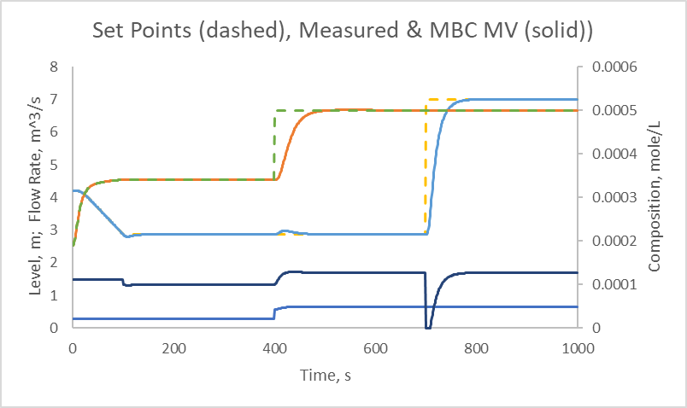

Figure 5 – Controlled Process

At a time of 400 s the composition SP changes. Note the coupled MV action that minimizes the disruption upset to the level. At a time of 700 s the level SP changes. Notice that the fairly aggressive control temporarily hit the lower flow rate constraint at 700 s.

Figure 5 reveals decoupling, handling nonlinearity, no steady state offset, and no windup upon hitting MV constraints; even when the simple controller (not the ACT2 optimization solution method) model does not include real process complexities.

Figure 6 represents the same conditions as Figure 5, except that it adds a significant rate-of-change (RoC) constraint to the titrant flow rate set point. Starting at the composition SP change at 400 s, it takes about 100 s to move to the desired value. The MV actions starting at 400 s do not make large steps, but ramp up in a coordinated manner. The Fo SP does not have a RoC constraint, and makes the same step change at the level SP change at 700 s.

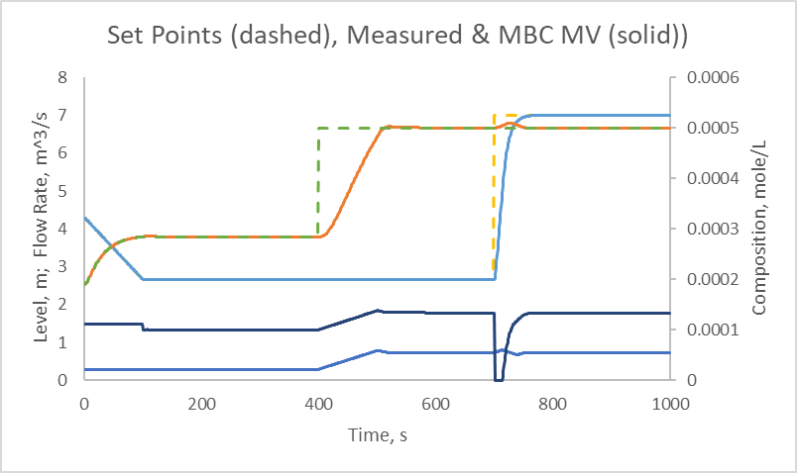

Figure 6 – With Rate-of-Change Constraint on Fo SP

Figure 7 illustrates the same sequence of events, but with continually changing values of the wild flow, the wild composition, and with measurement calibration drifts. Also, there is measurement noise on the level and three flow rates. The magnitude of the influent drifts is evident in the continually changing flow rate SPs during the extended periods where the level and composition SPs are held constant.

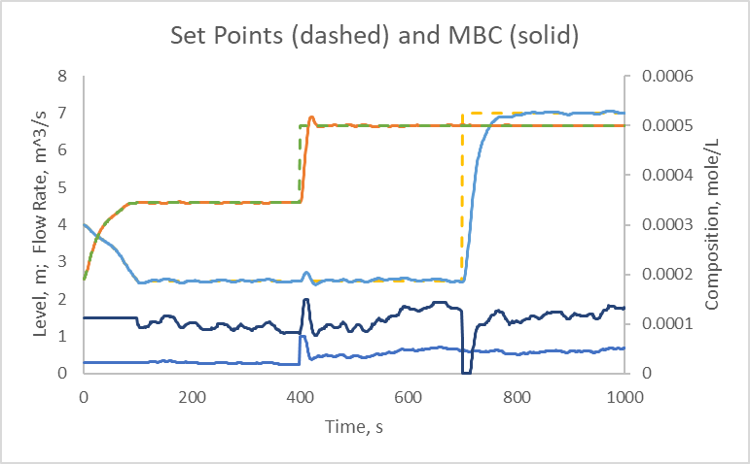

Figure 7 – Controlled Process with Disturbances

Figure 8 reveals control hitting a constraint, with disturbances active. Initially the controller is in MAN mode and switches to AUTO at 100 s. Since set point following is used in MAN mode, the controller set points are set at the CV values. The MBC controller manipulates the Ft and Fo set points for the secondary PI controllers to keep the process at the h and z set points. At a time of 200 s both h and z set points change. At a time of 400 s the composition set point goes to a high value. The Ft hits a high limit to increase z, but the Fo must also hit its high limit to try to preserve tank level. Both controller MVs are at their limits. At a time of 600 s the composition set point is changed and the titrant flow rate immediately responds, without any windup effects, to return composition to the set point. The Fo value stays at its upper limit, maximizing the rate that tank level returns to its set point, and just prior to hitting the h set point the Fo signal begins to back off. There is no offset at any of the fairly steady periods.

In PID control the integral’s job is to remove steady state offset, but it suffers from windup. With MBC there is no windup upon hitting a constraint, and no SS offset when unconstrained. In PID control the derivative’s job is to anticipate future CV values, and start taking action prior to crossing the set point. MBC shows the anticipatory action without derivative. MBC incorporates P, I, and D features, but with one controller tuning factor, the desired rate of change.

When processes are interactive, one PID controller can upset another. Advanced Classical Control solutions could be ratio, or decouplers. The MBC strategy naturally includes decoupling.

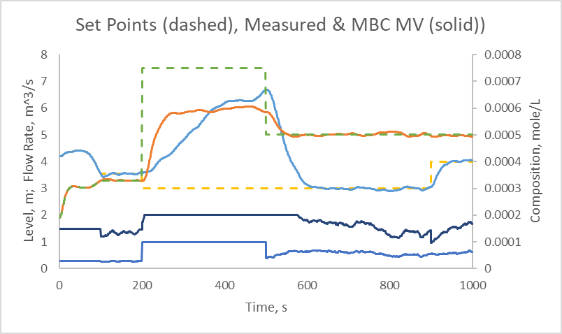

Figure 8 – Simple MBC control with Constraint

The simple version of the ACTION function during the constrained period (200 to 500 s) lets both CVs do what is natural when both MVs are at their limits. Notice that the flow rate set points (lower two traces) are at their maximum values, and that the tank level progressively rises to about 6.5 m.

However, if one CV is more critical than another (perhaps the tank level is near an overflow constraint, or the off-spec composition fluid must be diverted to a recycle tank stopping production) the ACT function could balance the control priority for the more critical CV. In this case optimization could be used to find the MV values that best meet the desired rate of change with a penalty for CV deviations from their SPs.

Figure 9 illustrates the same sequence of events as Figure 8 (although the noise and drift patterns are not the same). It shows how the optimization procedure solves for the MV values when considering constraints on tank level. The constraint is 5 m. Note that the level (the second from top solid line) does not violate the 5 m limit, and the out flow (second up from lowest) remains at its maximum limit, and that the titrant inflow is adjusted to prevent the level from exceeding its constraint, while remaining as high as possible to try to get the composition (the upper solid curve) to its set point.

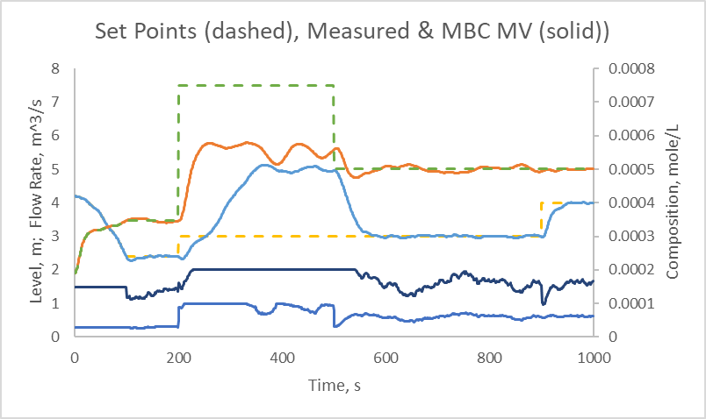

Figure 8 – Optimizing MBC control with Constraint

Conclusions

- The first-principles modeling supports other engineering activities, such as process analysis, identification of constraints, using supervisory RTO SS models that are consistent with those used by the controller, and operator and engineer training.
- The MBC approach has one tuning factor per CV, which relates the desired rate of return to the set point. This is a tuning advantage over PID, yet MBC has zero steady state offset and anticipatory action.
- The MBC approach naturally includes some advanced regulatory effects such as decoupling in multivariable processes, gain scheduling in nonlinear and non-stationary processes, and immediate recovery in an override situation.
- When constraints are encountered there is no windup. Recovery response is immediate when a constraint is removed.
- If there are no constraints, the simple MBC ACT function provides exactly the same control solution as that of the optimizing ACT function.
- The optimizing ACT function permits handling of both hard and soft constraints.
- If valve and pump models are included, the controller could calculate desired valve positions, which could go direct to the valves. But the cascade strategy illustrated here is preferred for flexibility, and to make use of the safety and communication features already embedded in traditional PID controllers.
- For bumpless transfer, in MAN mode the set points should follow their CVs, and after initialization of the model states at the process measurements, the models need to be calculated at each time-interval to incrementally update them to follow the process.
- The required engineering skill requires time domain modeling, elementary numerical methods, coding, and possibly optimization.
- The approach does not divert engineer or operator attention to understanding transformed or linear modeling mathematics, or to understand empirical linear or nonlinear modeling principles.
- Model development for empirical models requires substantial process testing. With only a few model coefficient values, validation or adjustment of first-principles models is much less costly.

Resources

For modeling, control, optimization, and on-line model adjustment: Rhinehart, R. R., Nonlinear Model-Based Control: Using First-Principles Models in Process Control, ISA Book Publications, estimated release 2Q2024.

For optimization: Rhinehart, R.R., Engineering Optimization: Applications, Methods, and Analysis, 2018, John Wiley & Sons, New York, NY, ISBN-13:978-1118936337, ISBN-10:1118936337, 731 pages with companion web site www.r3eda.com.

For the SPC filter: Muthiah, N., and R. R. Rhinehart, “Evaluation of a Statistically-Based Controller Override on a Pilot-Scale Flow Loop”, ISA Transactions, Vol. 49, No. 2, pp 154-166, 2010.

Primer on using Excel VBA: www.r3eda.com.

Using the Simulator

The blue highlighted cells at the top of the spreadsheet “PMBC CST Level and Composition …xlsm” are for the user to enter options and coefficients for the controller and the process. The file has a VBA macro, you’ll need to enable the macro to run the simuator.

Choose a trial number from the list of trials in the blue highlighted area in Rows 7-10, and enter it in the cell in Row2, Column 3. Cells(2,3). Odd numbered trials have ENVIRO OFF, which means no noise or disturbances. These represent ideal conditions. Even numbered trials with ENVIRO ON mean the simulation has both measurement noise and ARMA(1,1) disturbance patterns. These better represent reality, but the environmental effects may mask some details, and replicate runs are not duplicates, each has unique innovations. With Enviro ON, it may take several replicates to generate data useful for performance analysis. (Trial 11 runs 25 replicates with no set point changes to improve precision on the goodness metrics for the regulatory mode.)

In Cells(1,2) enter S for simple solution to the model inverse relations in the ACT function (Eqs. 22 & 23) or O for the optimization solution in the ACT function (Eq. 29).

Press the Run button to run the simulated trial.

If the controller is in the AUTO mode, the yellow highlighted cells provide goodness of control metrics. ISE is the integral of the squared CV deviation from set point. And Travel is the cumulative absolute value of the changes in the MV. Smaller values for both are better. If Enviro is OFF the ISE and Travel values are exactly repeatable. If ON, the values depend on the vagaries of the noise and disturbances. Trial 11 runs the simulation for 25 periods and sums the ISE and Travel values to reduce uncertainty.

Nominally for Trial 11, the coefficient of variation, Cv=sigma/average, is about 1.5% for ISE and 0.3% for Travel. But this will change with your choices of tuning and environmental effects. If you wish greater precision, increase the number of runs Trial 11 by editing the VBA code (SUB Main, Nreplicates). The standard deviation scales as the square root of the number of trials. So, 100 trials will halve the sigma, $\frac{1}{2}=\sqrt{\frac{25}{100}}$, and 1,000 trials will reduce variation by a factor of about 6. If you are investigating changes and want to make definitive claims that one option is better than another, use a t-test on the ISE and Travel values.

You enter controller tuning options in Column 6. Tauw means tau-want, your choice of how fast the controller pushes the process to the new set point. (The tank area is about 10 m², and if the liquid level is 5 m the volume is 50 m³. If the flow through is 1.5 m³/s, then the mixing time constant is about 30 s. Choosing the controller to have a tauwant of 20 s is asking it to push the process back to the set point a bit faster than it would naturally move.) Smaller Tauw values means a more aggressive controller.

Continuing in Column 6, SPC Trigger is the number of sigmas accumulated prior to implementing the controller-directed change. This is an internal override for noise filtering grounded in statistical process controller (do not make a change until you are very certain it is justified). It is not fundamental to MBC, and can be used to temper any noisy signal, even a controller output. If the measurements are noiseless then the controller output noise is zero, and every action is implemented. If the controller output is noisy, then the MV value is only changed when there is about a 95% confidence (2-sigma) that the change is statistically justified. If the pmm is noisy, you have an option to use a first-order filter to temper the noise. If the fictitious Ferror is noisy, then again you can use a first order filter. The two “filt tau” cells are the filter time-constants. Over the 1,000 s simulation, small “filt tau” values (such as 1 or 2) have no noticeable on the controller goodness metrics. Note also that filtering measurements is not just a feature of MBC. You can filter inputs to any controller to temper the impact of noise.

To the right of the blue highlighted cells (where you enter values) are not-highlighted cells with represented values and units.

Column 10 lets you choose the noise level on flow rate and level measurements. Roughly 5 standard deviations represent the range on the noise. For example, if sigma is 0.1 then 0.1*5 is 0.5, so the measurement ranges between +0.25 and -0.25 about the nominal value. I use the Box-Muller method to generate NID(0,sigma) noise at each sampling. The composition sensor is noiseless.

Column 14 allows you to determine the environmental drift on process influences. I use an ARMA(1,1) model driven by Gaussian noise to generate a disturbance addition to the nominal process influence value. The range value is the high less the low value, and the tau is the time-constant for the perturbation to persist.

In Column 18 you can enter process behaviors. Valve tau is the time-constant for the valve to move. “Vdead fraction” is the volume fraction in the CST that is the dead zone, and Fexchange is the flow rate between the active and dead zones. The supervisor MBC specifies set points for the secondary PI flow controllers. Both have the same tuning. Enter PI controller gain and integral time also in Column 18.

Measurements will have noise. Enter the first-order filter time-constant for noise filtering in Column 22. The composition measurement is not noisy, I imagine it to have a lag. In Cells(3,22) you enter the lag time-constant.

Finally, if optimization is chosen as the ACT method to determine MV values, then Column 26 is where you enter optimizer coefficient values. ECz and ECh are the equal concern values for the rate of change $∆$ terms in the OF. And EChconstraint is the EC factor for a level violation. Converg is the threshold for the optimizer to declare convergence. It represents the incremental change to the DVs. Finally RoC is where you enter the rate-of-change value for the FtSP and FoSP, the units are m^3/s/control interval.

If you wish to change inlet or titrant composition, or tank area, or any of many other values, you need to edit the assignments in the “Initialization” subroutine by opening the VBA editor.

Graphs

Graphs in the Spreadsheet reveal trends w.r.t. time.

There are five variables related to the outlet composition. 1) The actual outlet composition cannot be known. But in a simulation, we can see it. So, to help understanding, its curve is in dots, indicating this cannot be seen in a real process. 2) The measured value is what can be seen, and it is represented by a solid line. The measurement has bias, lag, and possibly noise. So the measured variable is not the true value. 3) The model calculates a value for the outlet composition, but because of model mismatch and errors on the model inputs, the model-calculated value is not the same as either the true value or the measured value. Model calculated variables are also solid lines. 4) There is a set point for the composition leaving the tank. This is a dashed line. The controller tries to make the measured value match the set point. But because the measured value is not the true value, the process will not actually be at the set point. This is not just a feature of MBC, any controller tries to make the measurement match the set point. 5) Because of pmm, the set point for the modeled composition value is different from the true set point. The biased set point, the set point for the model output, is also a dashed line, but it is thinner than the set point line.

There are also 5 such variables for the level. And two for any measurement (true and measured) such as a flow rate.

In the upper left, “Disturbances” reveal how the wild flow rate and composition change in time. These are the true values that cannot be known. Fw can be measured, but the measurement has noise and calibration error. zw is not measured.

In the upper middle, “Set Points (dashed), Measured and MBC (solid)” displays the MBC controller set points for level and composition, measured level and composition values, and the MBC MVs which are the set points for the secondary flow controllers for Fo and Ft.

In the upper middle, “Actual (dotted), MBC Modeled & MV (solid)” shows the actual level and composition. If there were no modeling error the Level and composition traces would match. But there is measurement calibration and model error. The controller keeps the measured values at the set point. If the measured does not match the actual, it is not a controller problem. In a real process, one cannot know the true value.

In the upper right, “Iterations to Converge” shows how many iterations the controller using optimization took to converge. Fewer is better, because it means less computer time. You can get fewer by increasing the convergence criterion, but loose convergence could be noticeable as continual variation about the right flow rate set points for the secondary controllers. The flow rates have a 0-2 range. A error that would not be visible in watching the process response would be about 1,000th of that. So a good value for the convergence would be 0.001. Smaller values provide better precision in the solution, which may be noticeable when Enviro is OFF, but inconsequential improvement with Enviro ON. With convergence set at 0.0001 the number of iterations is about 15, when relaxed to 0.001 the number of iterations is about 9.

In the lower left, “SP Actual (solid) and Biased (dashed)” shows the set point for the process and the biased set point for the model.

In the lower middle, “Ferror (filt) and other Flow Rates” show the three measured flow rates and the fictitious flow rate calculated by data reconciliation to make the material balance for the model make sense.

In the lower right, “Actual (dotted) and Measured (solid)” contrasts the two. If there were no measurement error, these would match. But they do not. The controller keeps the measured values at the set point. If the measured does not match the actual, it is not a controller problem.

